**Project Folder Structure**

**MVC + S Design Pattern**

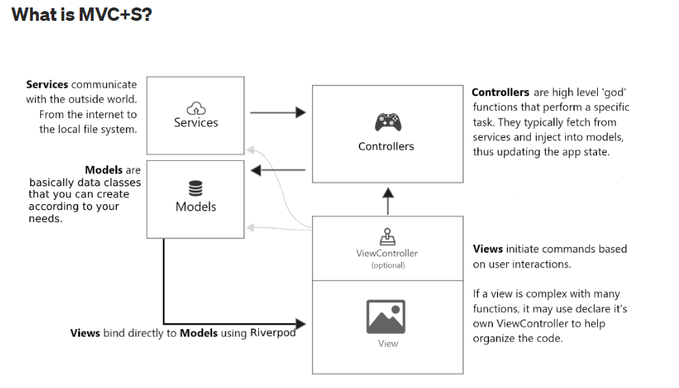

**Model**

Model are data classes that you create according to your needs. With the help of controller, you can manipulate the model’s data.

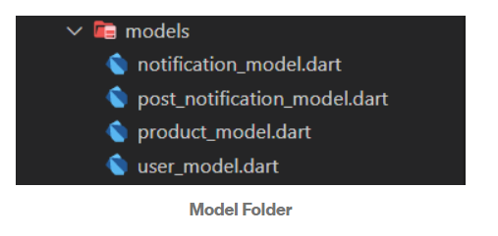

**View**

View are all the Widgets and Pages within the Flutter Application. These views may contain a “View controller” themselves, but that is still considered part of the view application tier.

All the UI part is in here.

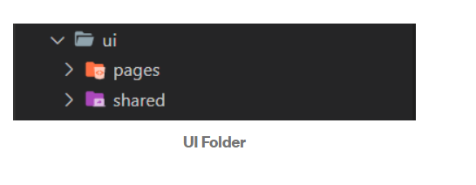

**Controller**

The controller layer is ahigh-level functions that perform a specific type of task. They typically fetch from services and inject them into models and that the way they control and update app state.

State management logic goes in here. You may place your logic for providers, bloc or any other state management logic into this folder.

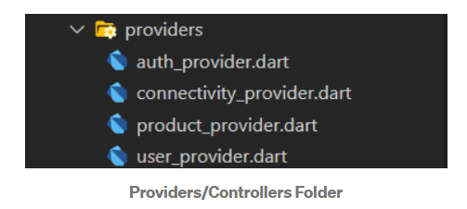

**Services**

Service fetch the data from the outside world and return it to the app.

Comments call on services and inject the results into the model. Services do not touch the model directly.

Whatever data that comes into your app must have to be from here. It may be connecting eith REST API r any DB connection.

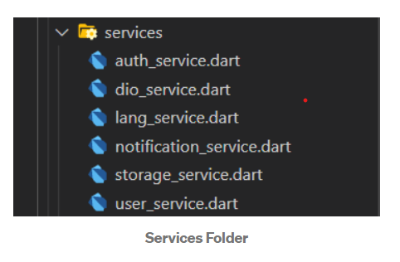

That’s the most basic way to achieve the MVC+S Pattern.